Statistics and Probability
Chapter 1
Exercise 1.1 Statistics Basics
Statistics
Statistics is a science of data in which learn methods or procedure used to collect, present, summarize, analyze and predict that data.
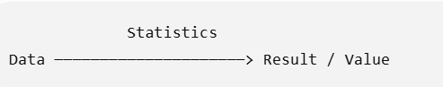
Population Vs Sample
1. Population
In statistics, population means the entire group of people, objects, or things that we want to study.
Example of Population
- Suppose we want to study the marks of BSE Fall 2023 students registered in MTH262.
- Population: All BSE Fall 2023 students registered in MTH262.
2. Sample
A sample means a small group of people or objects selected from a larger population for a study.
Example:
If there are 200 BSE Fall 2023 students registered in MTH262, and we collect information from 70 students, then:
- Population = 200 students
- Sample = 70 students
3. What is Sampling?
Sampling is the process of selecting a smaller group (sample) from a larger group (population) to collect data and study it.
Example:
If a university has 5,000 students, we select 200 students to conduct a survey.
- 5,000 students = Population
- 200 students = Sample
- Selecting the 200 students = Sampling
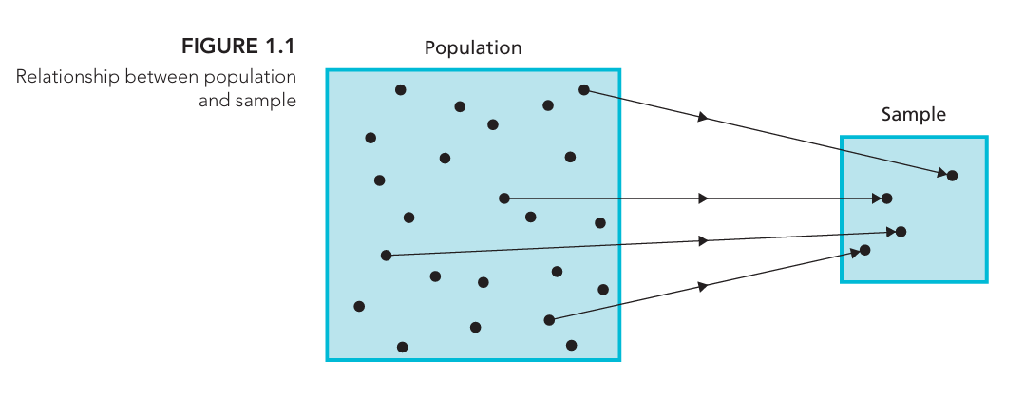
Types of Statistics
1. Descriptive Statistics
Descriptive statistics is the branch of statistics that collects, organizes, summarizes, and presents data so that it is easy to understand.
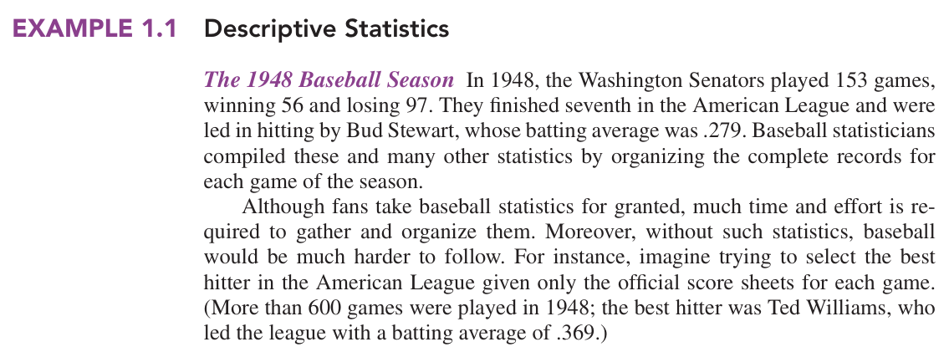
Example 1.1 (Easy Explanation of Above Example)
In 1948, the Washington Senators played 153 baseball games.
The collected data was:
- Games played: 153
- Games won: 56
- Games lost: 97
- League position: 7th
- Best hitter for the Senators: Bud Stewart
- His batting average: .279
Baseball statisticians collected and organized the records of all the games and summarized them using numbers such as wins, losses, and batting averages.
This is Descriptive Statistics because they are describing and summarizing the data that was collected.
Why is it useful?
Imagine having the score sheet for more than 600 games and trying to find the best hitter manually. It would be difficult.
Statistics makes it easier by summarizing the information. For example:
Ted Williams had a batting average of .369, which was the highest in the American League in 1948.
2. Inferential Statistics
Inferential statistics uses data from a sample to make conclusions or predictions about a larger population.
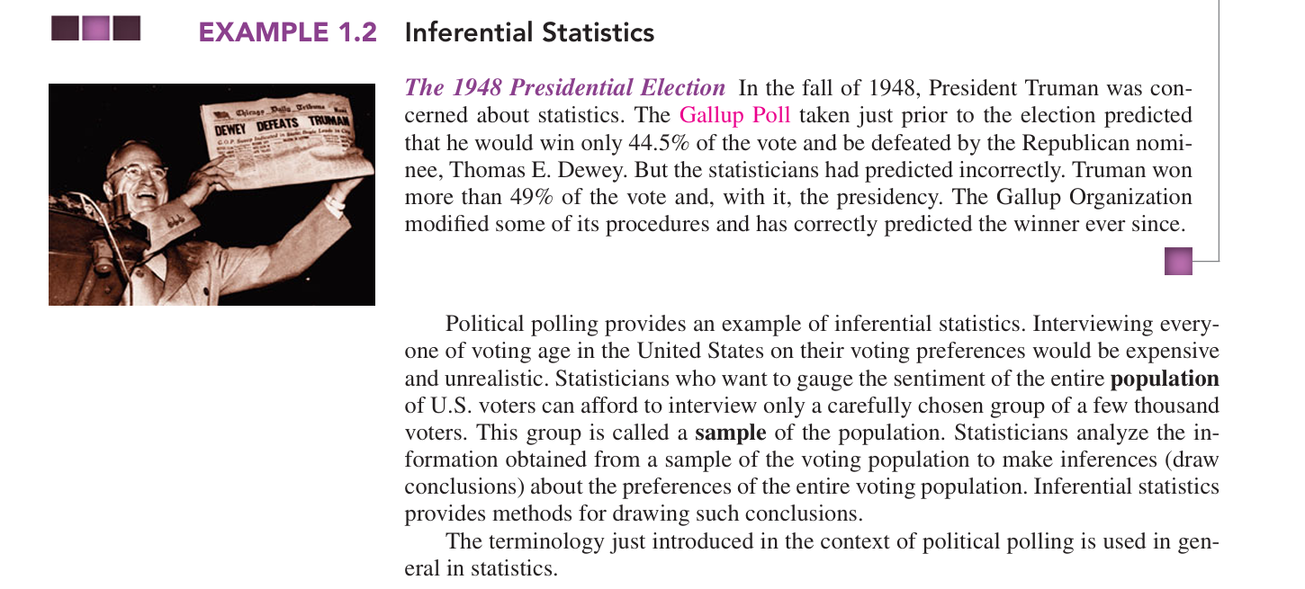
Example: 1948 Presidential Election (Easy Explanation of Above Example)
In 1948, Harry Truman was running for president against Thomas E. Dewey.
The Gallup Poll wanted to predict who would win. But they could not ask every voter in the USA, because there were too many people.
So, they:
- Selected a small group of voters → Sample
- Asked them who they planned to vote for
- Analyzed their answers
- Used the sample results to make a conclusion about ALL voters → Population
The poll predicted that Truman would get only 44.5% of the vote and would lose.
But the actual result was that Truman won more than 49% and became president.
Why is this Inferential Statistics?
Because they used information from a small sample to make a conclusion about the whole population.
Sample → Analyze data → Make conclusion about Population
More on Descriptive Statistics
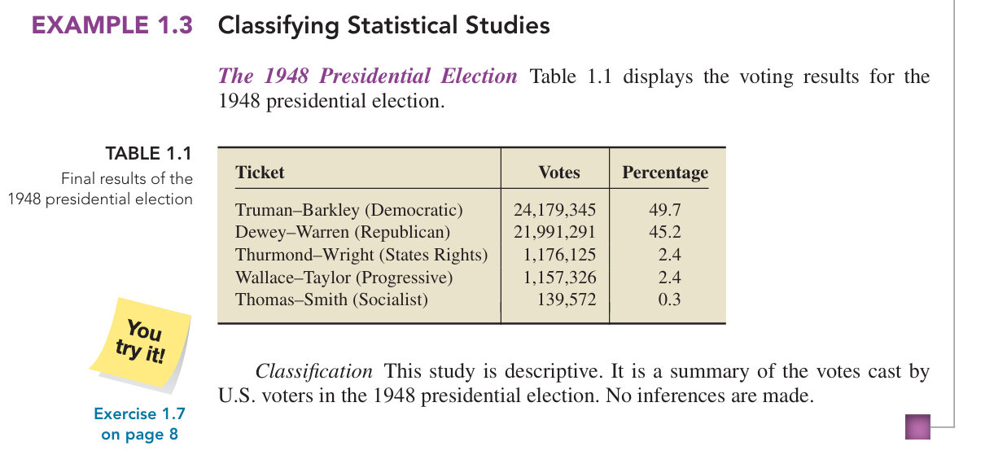

More on Inferential Statistics
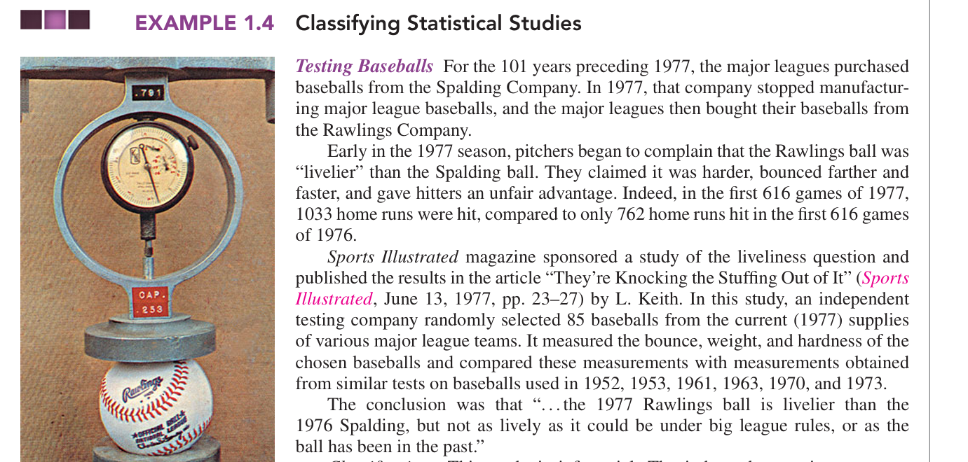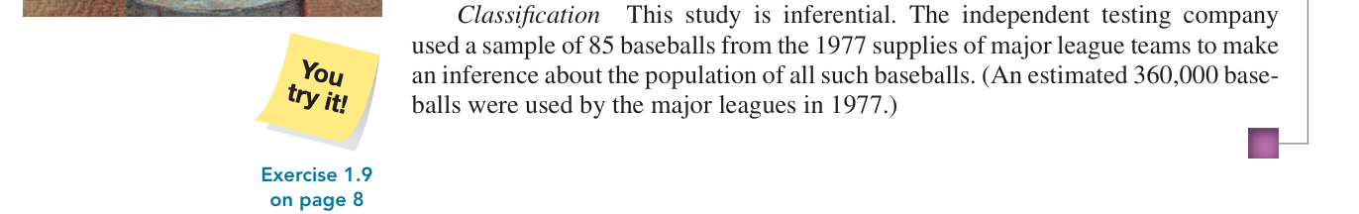
Shorter Version of Above Case Study
In 1977, pitchers complained that the new Rawlings baseball was “livelier” than the previous Spalding baseball. To investigate, an independent testing company randomly selected 85 baseballs from the 1977 supplies of major league teams and measured their bounce, weight, and hardness. Since it was not practical to test all 360,000 baseballs, the researchers used the sample of 85 to make a conclusion about the larger population. Therefore, this study is Inferential Statistics.
Types of statistical studies
1. Observational Study:
Researchers only observe and collect existing data. They do not change anything or give treatments. It can show an association (relationship) but usually cannot prove causation (cause and effect).
Example: Researchers compare men who already had a vasectomy with men who did not and observe their prostate cancer rates.
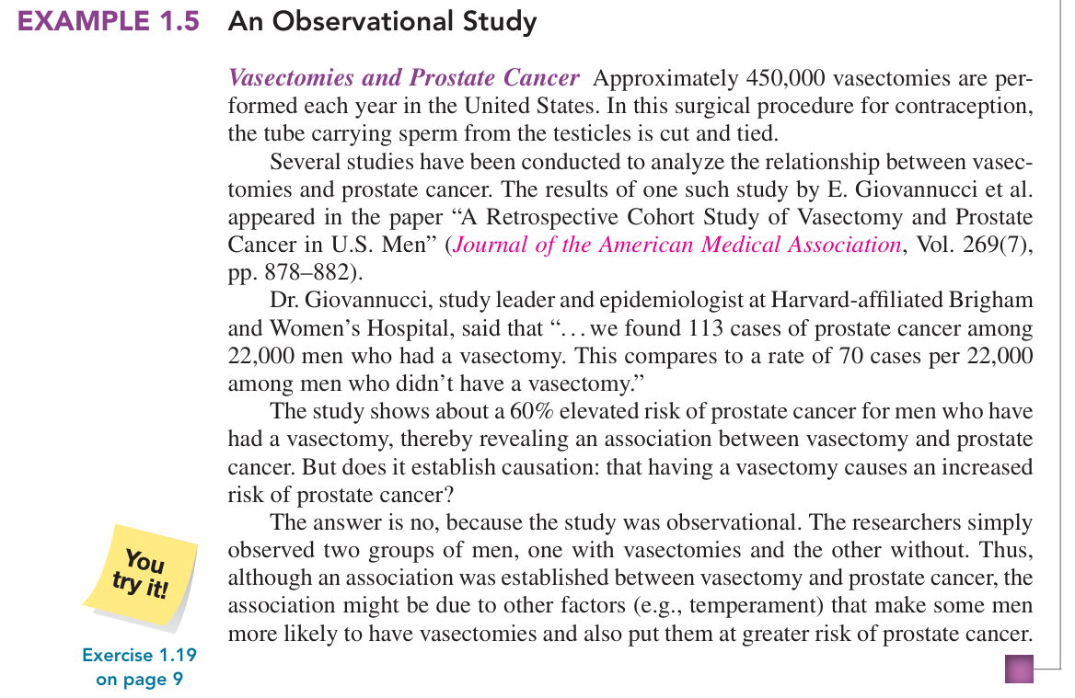
Shorter and Easier Explanation of Above Case Study
This study examined whether there was a relationship between vasectomy and prostate cancer. Researchers observed two groups of men: about 22,000 men who had a vasectomy and men who did not. They found 113 cases of prostate cancer among men with vasectomies compared with 70 cases per 22,000 among those without. However, the researchers did not assign or control who received a vasectomy; they simply observed existing groups. Therefore, it is an Observational Study, and it can show an association, but it cannot prove that vasectomy causes prostate cancer.

Vasectomy and Prostate
Vasectomy is a surgical procedure for male birth control. It involves cutting or blocking the tubes that carry sperm, so sperm cannot enter the semen.
Prostate is a small gland in the male reproductive system, located below the bladder. It helps produce the fluid that carries sperm.
2. Designed Experiment:
Researchers actively give treatments or make changes and then observe the results. This can help determine causation.
Example: Researchers give one group of patients a new medicine and another group a placebo, then compare their results.
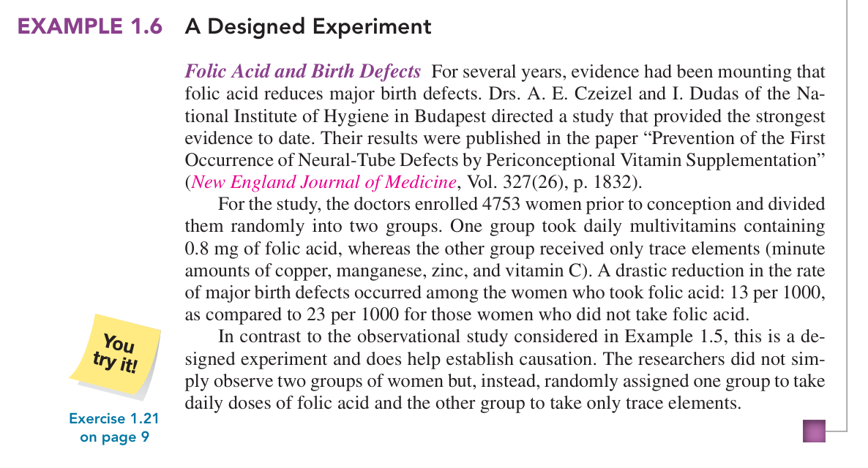
Shorter and Easier Explanation of Above Case Study
In this study, 4,753 women were randomly divided into two groups. One group took folic acid, while the other received only trace elements. The researchers then compared birth-defect rates: 13 per 1,000 with folic acid versus 23 per 1,000 without it. Because the researchers gave different treatments and randomly assigned the women, this is a Designed Experiment and provides evidence of causation.
Folic acid
Folic acid is a type of vitamin B (B9) that is important for the body.
In pregnant women, it helps the baby’s brain and spinal cord develop properly and can reduce the risk of certain birth defects.
Exercise Questions
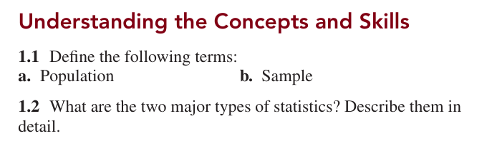
1.4 Explain two ways in which descriptive statistics and inferential statistics are interrelated.
Descriptive and inferential statistics are interrelated in the following two ways:
- Descriptive statistics summarize sample data.
For example, if we collect the marks of 100 students, we can calculate their average marks. This describes the data of those 100 students.
- Inferential statistics use sample data to draw conclusions about a population.
The results from those 100 students can be used to make conclusions or estimates about the marks of all students in the university.
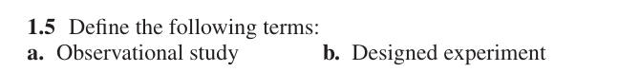
1.6 Fill in the following blank: Observational studies can re veal only association, whereas designed experiments can help establish
Ans: Causation.
Example
Suppose we want to know whether exercise helps improve exam marks.
- Observational study: We observe students and notice that students who exercise more often also tend to get higher marks. This shows an association, but we cannot say exercise is the cause because other factors may be involved.
- Designed experiment: We divide students into groups and give one group a planned exercise program while keeping other conditions similar. If the exercise group performs better, the experiment can provide evidence of causation.
In Exercises 1.7–1.12, classify each of the studies as either descriptive or inferential. Explain your answers.
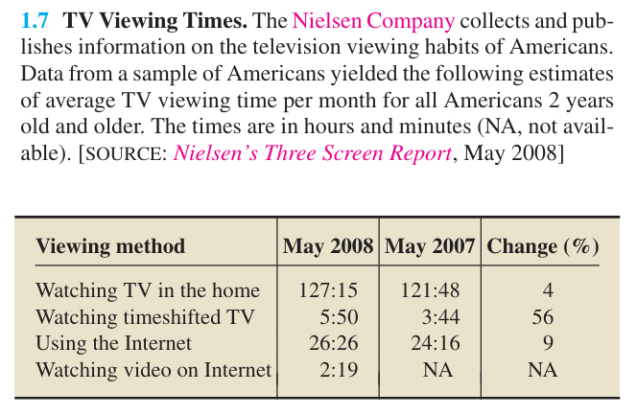
Answer: Inferential statistics.
Why? The Nielsen Company collected data from a sample of Americans and used it to estimate the TV viewing time of all Americans aged 2 and older.
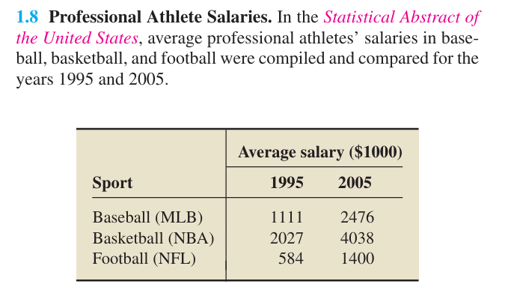
Answer: Descriptive statistics.
Why? The study compares the average salaries of professional athletes in baseball, basketball, and football for 1995 and 2005.
It is only summarizing and comparing the available salary data; it is not using a sample to make conclusions about a larger population.
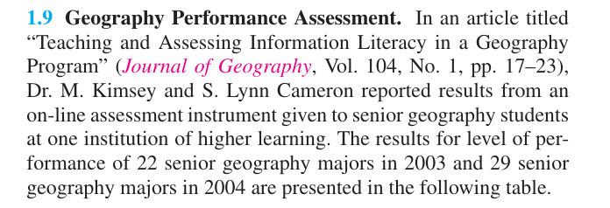
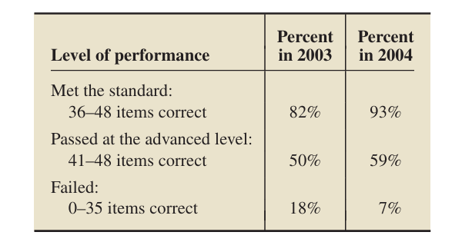
Answer: Descriptive Statistics
Why? The researchers collected and summarized the performance results of 22 students in 2003 and 29 students in 2004 at one institution. They presented the results using percentages.
They are describing the students' performance, not using the sample to make conclusions about a larger population.
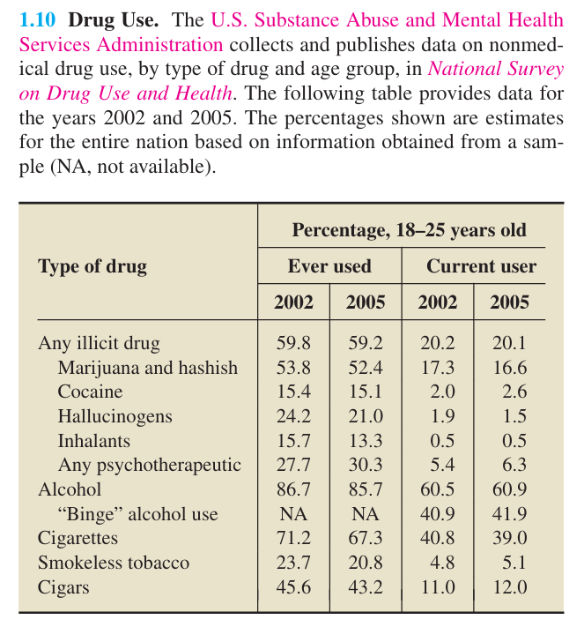
Answer: Inferential Statistics
Why? The data is collected from a sample of people, but the percentages are used to give estimates for the entire nation.
They use sample information to make conclusions about the larger population.
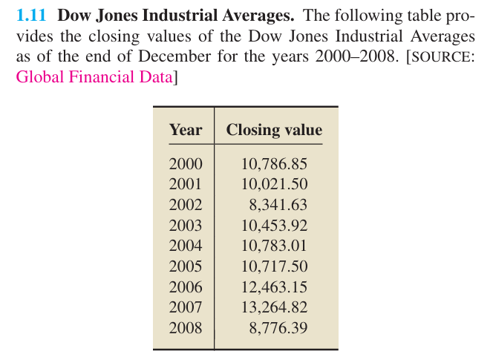
Answer: Descriptive Statistics
Why? The table simply shows the closing values of the Dow Jones Industrial Average from 2000 to 2008. It summarizes the recorded data for those years.
It does not use a sample to make conclusions about a larger population.
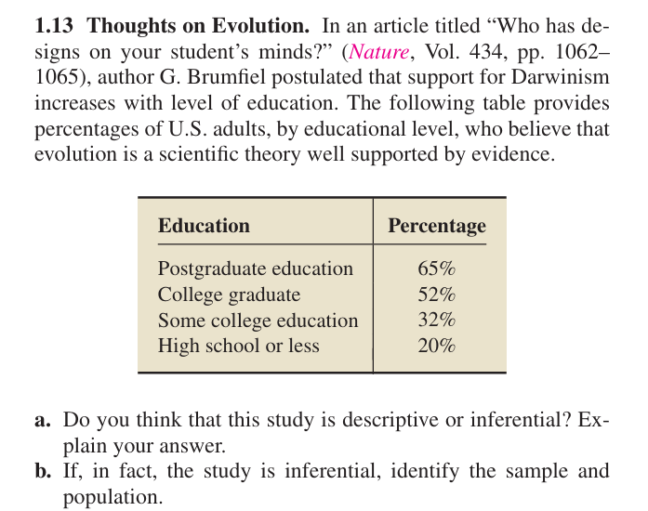
a. Answer: Inferential Statistics
Why?
The study uses data from U.S. adults to make a conclusion about the relationship between education level and support for evolution among the larger population of U.S. adults.
b. Sample and Population
- Sample: The U.S. adults who were included in the study/survey.
- Population: All U.S. adults.
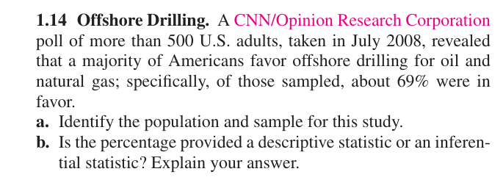
a. Population and Sample
- Population: All U.S. adults.
- Sample: The more than 500 U.S. adults who participated in the poll.
b. Answer: Inferential Statistics
Why?
The 69% was calculated from the sample of more than 500 adults and is used to estimate the opinion of all U.S. adults.

Exercise 1.2 Simple Random Sampling
Sampling Unit?
A sampling unit is the individual person, object, or item that can be selected from a population for a sample.
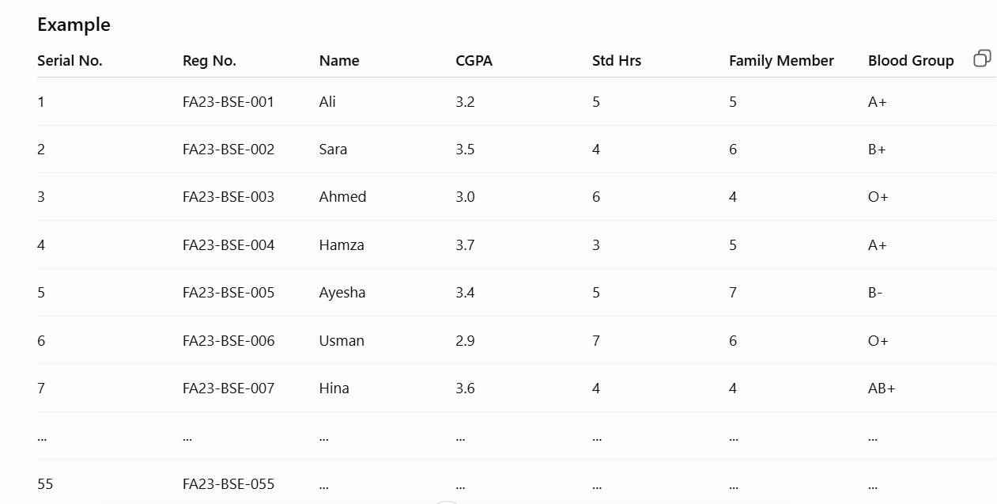
Population: All 55 students of FA23-BSE
Sample: The 7 students you selected
Sampling unit: One student
Sampling: The process of selecting those 7 students from the 55 students
Sampling Frame?
A sampling frame is a complete list of all the sampling units in a population from which we select our sample.
Sampling frame: The table/list containing all 55 students with their registration numbers, names, etc.

Census?
A census is a study in which we collect data from every member of the population.
Using your FA23-BSE example:
- Population: 55 students
- Census: Collect information from all 55 students
- Sample: Collect information from only 7 students
Sample Survey?
A sample survey is a survey in which we collect data from only a sample of the population, instead of everyone.
Using your FA23-BSE example:
- Population: 55 students
- Sample: 7 selected students
- Sample survey: Collect information from those 7 students.
Parameter vs Statistic
1. Parameter
A parameter is a value calculated from complete population data. Because the population is fixed, its parameter is considered fixed.
Example:
Suppose a university has 10,000 students, and we calculate the average CGPA of all 10,000 students.
That average is a parameter.
If the population doesn't change, the parameter doesn't change.

2. Statistic
A statistic is a value calculated from sample data. If we take different samples, we can get different results. Therefore, a statistic is considered variable.
Example: If we select 7 students from the 55 and calculate their average CGPA, that average is a statistic.
Parameter = Population = Fixed
Statistic = Sample = Can change
Experiment?
An experiment is a study in which we change or control something and observe its effect on another variable.
Example:
Suppose we want to know whether more study hours improve CGPA. We give some students a specific study schedule and then compare their CGPA with other students.
Representative Sample?
A representative sample is a sample that properly reflects the important characteristics of the population.
Example:
Suppose there are 55 students in FA23-BSE, with different CGPAs, study hours, and backgrounds. If we select 7 students in a way that reasonably represents the different types of students in the class, those 7 students form a representative sample.
Homogeneity and Heterogeneity
These terms describe how similar or different the members of a population are.
1. Homogeneity
Homogeneity means the members are similar to each other.
Example:
A class that includes only male students is homogeneous because the students have a similar characteristic.
2. Heterogeneity
Heterogeneity means the members are different from each other.
Example:
A class that includes both male and female students is heterogeneous because the students have different characteristics.
Sampling Techniques: Probability Sampling vs Non-Probability Sampling
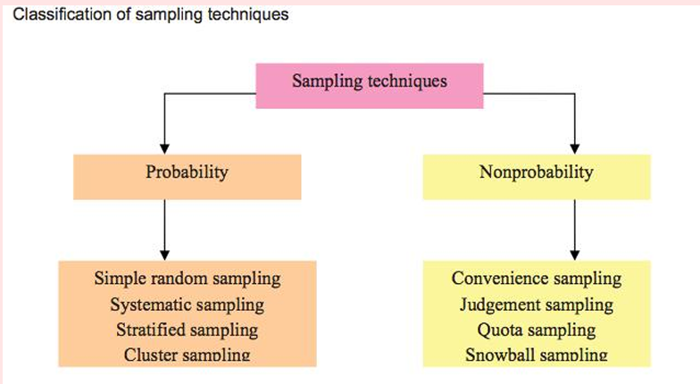
1. Probability Sampling
Every member of the population has a known chance of being selected, usually through random selection.
Example:
There are 55 students in a class. You randomly select 7 students using a lottery or random number generator.
Every student has a chance of being selected.
2. Non-Probability Sampling
Members are selected without random selection, so some members may have no known chance of being selected. The selection may depend on the selector's choice or preference, so it can be biased. Therefore, we cannot reliably generalize the results to the whole population.
Example:
A class has male and female students, but the selector chooses only male students for the sample.
This is non-random sampling because the selector chooses who to include.
Types of Probability Sampling
Simple Random Sampling
Every member of the population has an equal and known chance of being selected.
Example:
There are 55 students in a class. We need a sample of 7 students. We write all 55 names on slips and randomly pick 7 slips.
Everyone has an equal chance of being selected.
Simple random sample
A sample obtained by simple random sampling.

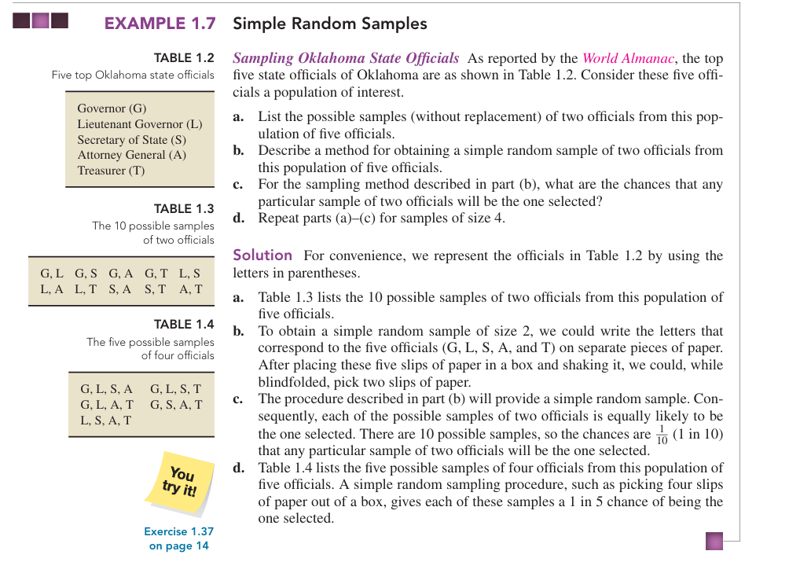
Exercise Set 1.2
1.27 Explain why a census is often not the best way to obtain information about a population.
A census means collecting information from every member of a population.
It is often not the best way because it can be expensive, time-consuming, and difficult to study everyone. A sample can provide information about the population more quickly and at lower cost.

1.28 Identify two methods other than a census for obtaining information.
Two methods other than a census for obtaining information are:
- Sample survey
- Experiment
1.29 In sampling, why is obtaining a representative sample important?
A representative sample is important because it accurately reflects the characteristics of the whole population.
It helps us make correct conclusions about the population from the sample.
1.30 Memorial Day Poll. An online poll conducted over one Memorial Day Weekend asked people what they were doing to observe Memorial Day. The choices were: (1) stay home and relax, (2) vacation outdoors over the weekend, or (3) visit a military cemetery. More than 22,000 people participated in the poll, with 86% selecting option 1. Discuss this poll with regard to its suitability.
Answer
This poll is not suitable for representing the whole population because it is an online voluntary poll. People choose themselves whether to participate, so the sample may be biased.
Also, people who were staying home were more likely to see and answer the online poll than people who were outdoors or visiting a cemetery.
Therefore, the 86% result cannot be generalized to the entire population.
1.31 Estimating Median Income. Explain why a sample of 30 dentists from Seattle taken to estimate the median income of all Seattle residents is not representative.

This sample is not representative because it includes only dentists, while the population includes all Seattle residents. Dentists may have different incomes from other residents.
Therefore, the sample does not properly represent the whole population.
1.32 Provide a scenario of your own in which a sample is not representative.
Answer
A teacher wants to know the average marks of all students in a class, but selects only 10 students who got the highest marks.
This sample is not representative because it does not include students with average or low marks.
1.33 Regarding probability sampling:
a. What is it?
b. Does probability sampling always yield a representative sample? Explain your answer.
c. Identify some advantages of probability sampling.
a. What is probability sampling?
Every member of the population has a known chance of being selected, usually through random selection.
b. Does it always give a representative sample?
No. Probability sampling does not always give a representative sample. A sample can be selected randomly but still, by chance, not perfectly represent the population.
c. Advantages of probability sampling:
- It reduces bias in selecting the sample.
- Every member has a known chance of selection.
- It allows us to generalize results from the sample to the population.
- It is more reliable and objective than non-probability sampling.
1.34 Regarding simple random sampling:
a. What is simple random sampling?
b. What is a simple random sample?
c. Identify two forms of simple random sampling and explain the difference between the two.
a. What is simple random sampling?
Every member of the population has an equal and known chance of being selected.
b. What is a simple random sample?
A sample obtained by simple random sampling.
c. Two forms of simple random sampling:
- Sampling with replacement:
After selecting a member, we put them back before selecting again. So, the same member can be selected more than once.
- Sampling without replacement:
After selecting a member, we do not put them back. So, the same member cannot be selected again in the same sample.

1.36 Identify two methods for obtaining a simple random sample.
Two methods are:
- Lottery method: Write the names/numbers of all population members on separate pieces of paper, mix them, and randomly select the required number.
- Random number method: Assign a number to each population member and use a random number generator/table to select the sample.
1.37 Question
Oklahoma State Officials. The five top Oklahoma state officials are displayed in Table 1.2 on page 12. Use that table to solve the following problems.
a. List the 10 possible samples (without replacement) of size 3 that can be obtained from the population of five officials.
b. If a simple random sampling procedure is used to obtain a sample of three officials, what are the chances that it is the first sample?
Answer
The five officials are:
G, L, S, A, T
a. 10 possible samples of size 3
- G, L, S
- G, L, A
- G, L, T
- G, S, A
- G, S, T
- G, A, T
- L, S, A
- L, S, T
- L, A, T
10. S, A, T
b. Chance of selecting the first sample
There are 10 possible samples.
Since simple random sampling gives every sample an equal chance:
$$P=\frac{1}{10}$$
So, the chance of selecting the first sample (G, L, S) is:
1 out of 10 = 10%.
1.38 Best-Selling Albums
The Recording Industry Association of America provides data on the best-selling albums of all time. As of January 2008, the top six best-selling albums of all time (U.S. sales only) are by the artists Eagles (E), Michael Jackson (M), Pink Floyd (P), Led Zeppelin (L), AC/DC (A), and Billy Joel (B).
a. List the 15 possible samples (without replacement) of two artists that can be selected from the six. For brevity, use the initial provided.
b. Describe a procedure for taking a simple random sample of two artists from the six.
c. If a simple random sampling procedure is used to obtain two artists, what are the chances of selecting P and A? M and E?
Answer
a. 15 possible samples of two
The six artists are: E, M, P, L, A, B
- E, M
- E, P
- E, L
- E, A
- E, B
- M, P
- M, L
- M, A
- M, B
10. P, L
11. P, A
12. P, B
13. L, A
14. L, B
15. A, B
So, there are 15 possible samples.
b. Simple random sampling procedure
Write the six initials (E, M, P, L, A, B) on separate pieces of paper. Put them in a box, mix them, and randomly pick two papers.
The two selected artists form the simple random sample.
c. Chances of selecting P and A / M and E
There are 15 possible samples, and each has an equal chance.
P and A:
$$\frac{1}{15}$$
M and E:
$$\frac{1}{15}$$
So, both samples have a 1 in 15 chance, or approximately 6.67%.

1.3 Other Sampling Designs
2. Systematic Random Sampling
Systematic Random Sampling is a probability sampling method where we select members at a regular interval after choosing a random starting point.
Method
Instead of randomly choosing every person separately, we:
- Find the interval $m$.
- Randomly choose a starting number $k$.
- Then select every $m$-th person.
Example
Suppose we have 100 students and need a sample of 10.
Step 1:
$$100÷10=10$$So, m = 10
Step 2:
Randomly choose a number from 1 to 10.
Suppose we get 4.
Step 3:
Start from 4 and select every 10th student:
4, 14, 24, 34, 44, 54, 64, 74, 84, 94
These 10 students are our systematic random sample.
2. Cluster Sampling
Cluster sampling is a probability sampling method in which the population is divided into groups called clusters, and some clusters are randomly selected for the sample.
Example:
A university has 20 classes. Randomly select 5 classes and collect data from all students in those selected classes.
Remember: Select some whole groups.
3. Stratified Sampling
Stratified sampling is a probability sampling method in which the population is divided into different groups (strata), and some members are randomly selected from each group.
Example:
A university has 600 male and 400 female students. To select 100 students, randomly select students from both male and female groups.
Remember: Some members from every group.
Why use stratified sampling instead of simple random sampling in case of Homogeneity?
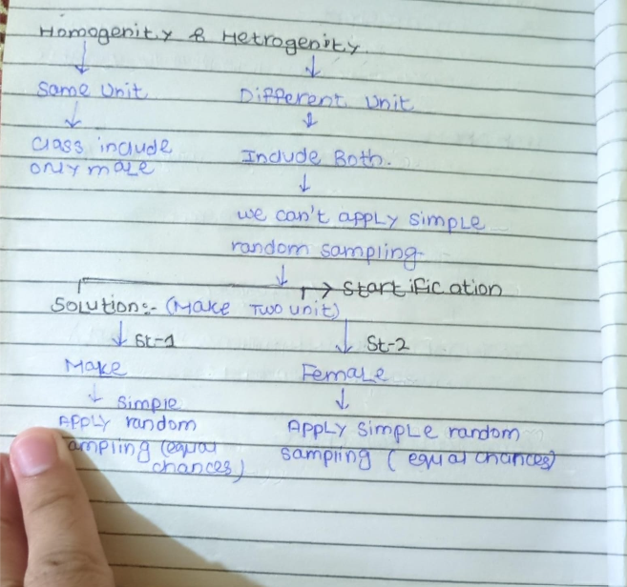
Suppose a university has male and female students:
- Population = 70% male, 30% female
- If we use simple random sampling, we randomly select students from the whole population.
- By chance, we might select more males and very few females.
- So, one group may not be properly represented.
Therefore, we divide the population into two homogeneous strata:
Stratum 1 → Male → apply simple random sampling
Stratum 2 → Female → apply simple random sampling
This is called stratified random sampling.

Key Note
When a population contains different groups, simple random sampling may not ensure proper representation of every group. Therefore, we divide the population into homogeneous strata and apply simple random sampling within each stratum. This is called stratified random sampling.
Exercise set 1.3
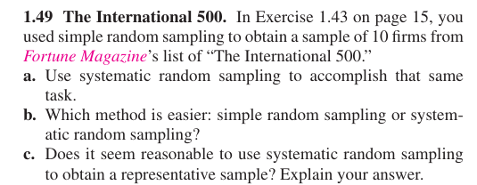
1.49 The International 500
There are 500 firms, and we need a sample of 10 firms.
a. Use systematic random sampling
Use the textbook's systematic sampling procedure: divide population size by sample size, randomly choose a starting number, then select every $m$-th member.
Step 1: Find $m$
$$m=\frac{500}{10}=50$$
Step 2: Randomly select a number from 1 to 50.
Suppose the random starting number is 22.
Step 3: Select every 50th firm:
$$22, 72, 122, 172, 222, 272, 322, 372, 422, 472$$So, these 10 firms form the systematic random sample.
b. Which method is easier?
Systematic random sampling is easier.
Because after selecting the random starting number, we simply select every 50th firm. The textbook also states that systematic random sampling takes less effort to implement than simple random sampling.
c. Is it reasonable for obtaining a representative sample?
Yes, generally.
Systematic random sampling usually provides results comparable to simple random sampling. However, it may not work well if the list has a cyclical pattern (repeating pattern).
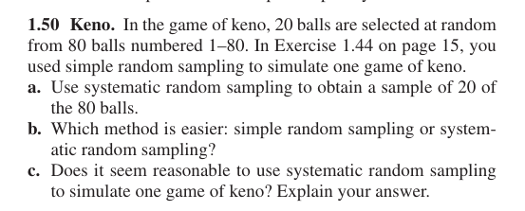
a. Use systematic random sampling
Step 1: Find $m$
$$m=\frac{80}{20}=4$$
Step 2: Randomly select a starting number from 1 to 4.
Suppose we randomly select 3.
Step 3: Select every 4th number:
$$3, 7, 11, 15, 19, 23, 27, 31, 35, 39, \\ 43, 47, 51, 55, 59, 63, 67, 71, 75, 79$$
These are the 20 balls selected.
b. Which method is easier?
Systematic random sampling is easier.
After choosing the starting number, we just select every 4th ball.
c. Is systematic random sampling reasonable for simulating keno?
No, not really.
In keno, balls are supposed to be selected at random. Systematic sampling forces the numbers to follow a fixed pattern, such as every 4th number. Therefore, it does not realistically simulate the random selection of a keno game.

